# Creating a Composition Profile

This tutorial will use this sample letter as a base for the composition. It is loosely based on the data interchanges between health and social care providers who contribute to the Leeds Care Record.

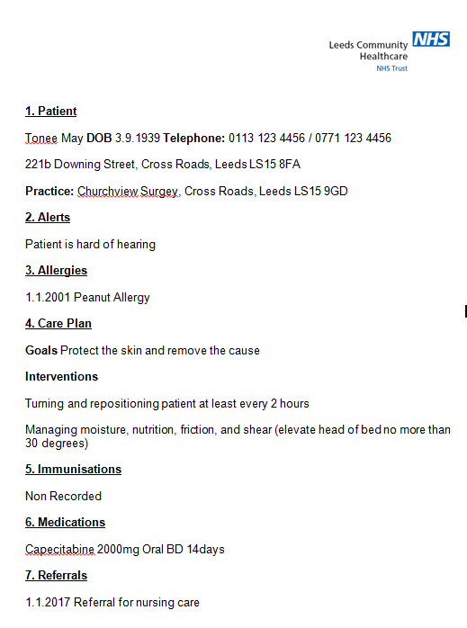

The letter consists of seven sections which may realise correspond to FHIR Resource’s; we will come back to this latter in this tutorial.

## Properties

In Furore Forge create a new profile based on Composition. On the properties tab:

* Add the url for the resource. E.g. <http://leedsth.nhs.uk/Dstu2/StructureDefinition/LTHT-Leeds-Care-Record-Composition-1>
  + Dstu2 shows the FHIR version which was used for the profile
  + Number at the end of the url allows for multiple versions of the profile.
* Add a Resource Id and Name. In this example we have used **LTHT-Leeds-Care-Record-Composition-1** which matches the url of the resource.
* Add copyright and publisher

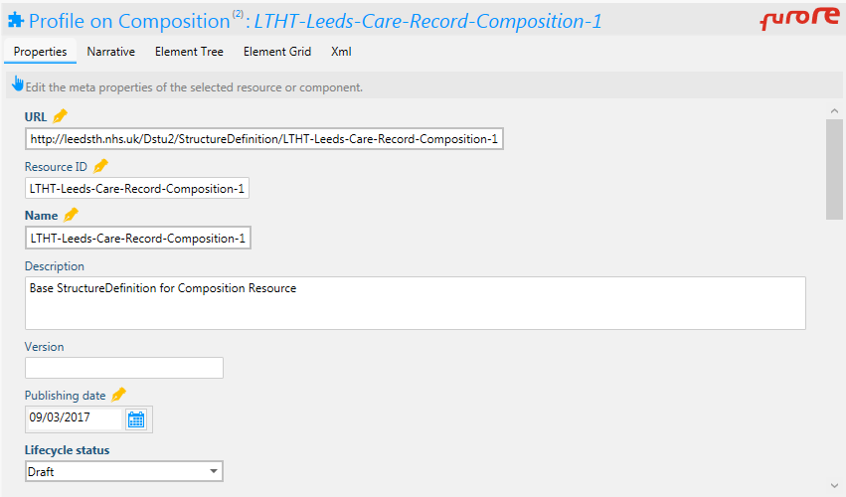

## Constrain the Profile

Next we need to constrain properties we don’t need in the profile. Set the cardinality to 0..0 for:

* implicitRules
* language
* test
* contained
* identifier
* attester
* event
* encounter

Similarly for the type and class entries set the code type to **http://snomed.info/sct** and the cardinality to 0..0 for

* id
* text
* coding
  + id
  + version
  + userSelected

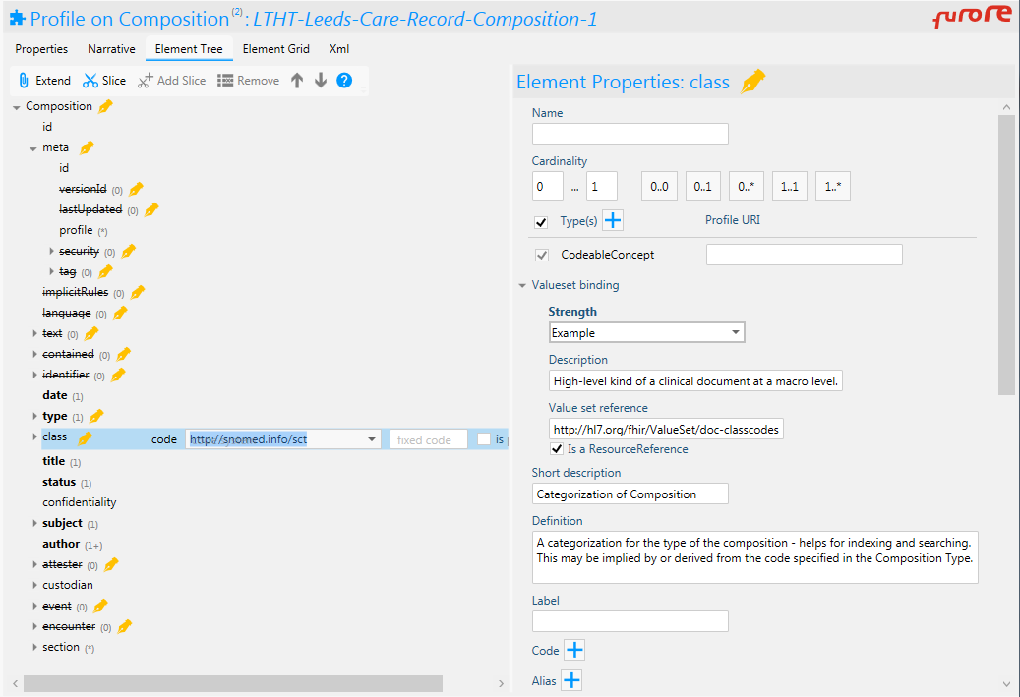

The constraints we’ve done so far match the GP Connect Composition profile (<http://fhir.nhs.net/StructureDefinition/gpconnect-carerecord-composition-1> ) and we will continue this and reuse the same ValueSets fopr type and class. These are:

type: <http://fhir.nhs.net/ValueSet/document-type-codes-snct-1>

([SNOMED RefSet=999000391000000109](http://browser.ihtsdotools.org/?perspective=full&conceptId1=999000391000000109&edition=uk-edition&release=v20161001&server=https://prod-browser-exten.ihtsdotools.org/api/snomed&langRefset=900000000000508004))

class: <http://fhir.nhs.net/ValueSet/care-setting-codes-snct-1>

([SNOMED RefSet=999000381000000107](http://browser.ihtsdotools.org/?perspective=full&conceptId1=999000381000000107&edition=uk-edition&release=v20161001&server=https://prod-browser-exten.ihtsdotools.org/api/snomed&langRefset=900000000000508004))

Add these valueset to the properties of type and class

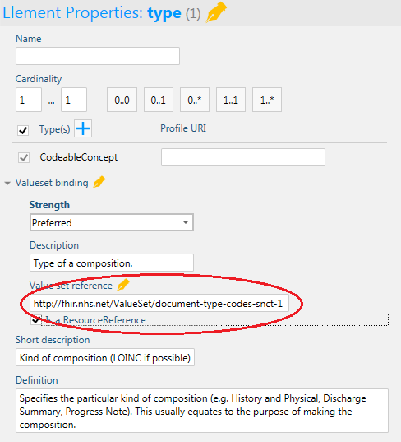

The contents of these value sets can be found in ITK Reference Set documentation, GP Connect documentation or use the SNOMED links above.

The type code in this instance will be *425173008 record extract (record artifact)*, these can be added to the type.

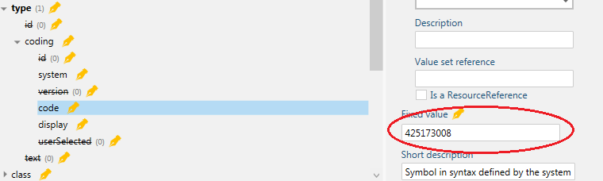

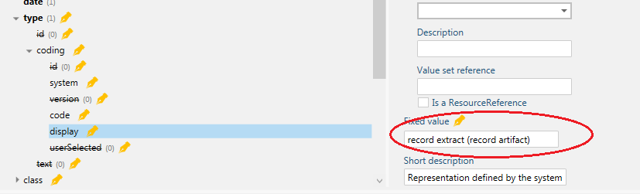

The code and display value will change depending on which organisation creates the composition, e.g. For Mental Health this could be *708168004 Mental health service (qualifier value).*

## Section - Slicing

Like CDA, FHIR Documents ideally contain both a human readable and structured information. The human readable portion is normally coded as html within the **Composition** with links to structured versions of the same information.

Firstly we will split up the letter into sections and assign a discriminator to differentiate each section. The sections are:

|  |  |
| --- | --- |
| Section Title | SNOMED CT Code and Display Term |
| Patient | 886731000000109 Patient Demographics |
| Alerts | 886931000000107 Safety Alerts |
| Allergies | 886921000000105 Allergies and adverse reactions |
| Care Plan | 887201000000105 Plan and Requested Actions |
| Immunisations | Nil - see note below |
| Medications | 933361000000108 Medications and Devices |
| Referrals | 886721000000107 Referral Details |

SNOMED Codes have been taken from RefSet: *999001721000000100 Standards for the clinical structure and content of patient records*

This reference set doesn’t have a suitable entry for immunisations for the purposes of this tutorial *304250009 Immunization Finding* will be used.

To split up the section entry of the profile, select *section* and then click on the *slice* button. The button should then change to *sliced* and section will have a pair of scissors which indicates it is sliced.

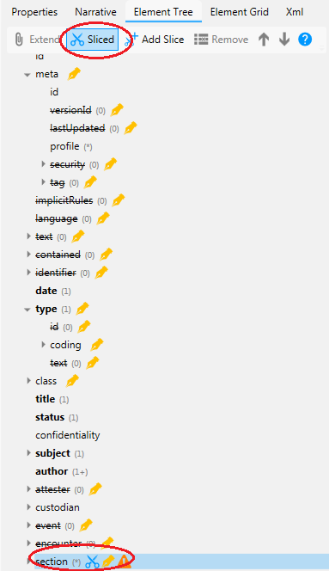

Next we need to specify how the sections are broken up. We’ve assigned a code to each section and so this can be used.



Ensure section is highlighted and then click on the Add Slice button. In the name box add Patient.

Remove the following sections by changing cardinality to 0..0

* Id
* code.coding.id
* code.coding.version
* code.coding.userSelected
* code.text
* mode
* orderdedBy
* entry
* emptyReason

Change coding cardinality to 0..1 and set the code system to SNOMED

Change the Value set reference to one pointing to the *999001721000000100 Standards for the clinical structure and content of patient records.* In the below this is <http://leedsth.nhs.uk/Dstu2/ValueSet/LTHT-ClinicalRecordHeadingsSimpleSnCT-1>

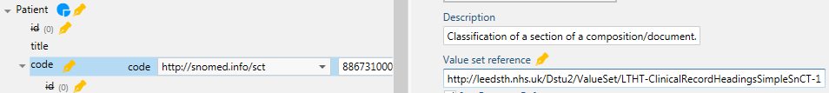

Set the coding.code to have a fixed value of *886731000000109* and coding.display to *Patient Demographics*

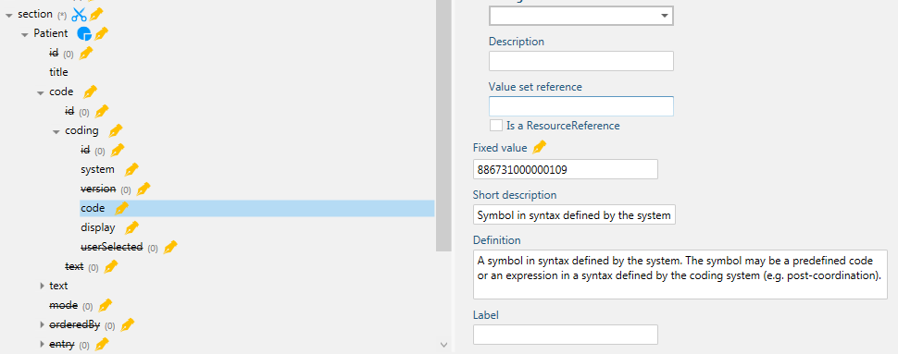

That’s it… or that’s how to do it for the next sections.